Colwinston News & Views April 2026 Issue 292

St Michael’s Church Service Dates

- Sunday 3rd May 9.15am
- Sunday 17th May 9.15am
- Sunday 7th June 9.15am

Everyone is welcome to attend.

Village Hall News

As I’m sure you have all seen our roof, PV panels, battery pack and car park have now been completed and we are really pleased with the results, it’s now time for us to do some tidying up and painting around the outside of the hall to finish it off, that will all be done before fete week.

We had a good April which started with a great day for the Easter egg hunt, amazing support from the village with 40 children joining in with the hunt lead by the Easter bunny and the Mad Hatter.

We then had a fantastic live music night on the 18th, it was nice to see so many people there letting their hair down and enjoying the live music, thanks again for your support.

Our next Event is Ascot Ladies Day (not just for ladies) on Thursday June 18th please contact Julie Lloyd or colwinstonvillagehall@gmail.com to book your space, all the info about that event and others that we have planned can be found at www.colwinstonvillagehall.com.

In case the information hasn’t reached you, yet this year’s Fete theme is Country & Western, so grab your hats, slip on your boots and get ready for a good old hoedown.

Dave Frost

Announcement

I will be taking over as Colwinston News and Views Editor. Thank you to Rhian Cleaver and her efforts as the previous editor over the last year.

If you want to contribute to the village news, with any Colwinston news, then please get in touch. I will be contactable on colwinstonnews@yahoo.com.

Miles Davies
Colwinston News and Views Editor

Colwinston Community Council

Dog Fouling in Colwinston

We’ve received several concerns recently about dog fouling around Colwinston. This includes not only dog waste left on footpaths and grass verges, but also bags of dog waste being left behind.

Bagging dog waste but then leaving it behind is still littering. It creates an unpleasant environment, poses health risks and detracts from the appearance of our village for residents and visitors alike.

Unfortunately, it also creates more work for volunteers who pick up litter around the village. We know the vast majority of dog owners in Colwinston are responsible and considerate.

We are simply asking everyone to:

- Clean up after your dog
- Take bagged waste home or place it in a bin
- Help protect the shared spaces we all enjoy

We would also ask parents to please pass this message on to children who may be walking dogs on their behalf, so they are aware of the importance of disposing dog waste properly. Let’s all play our part in keeping Colwinston clean, safe and pleasant for everyone.

A Tree for Carl

A tree in memory of Councillor Carl Hadley has been planted at the Old Ford. Councillor Carl is missed by all of us, and we were pleased to support the tree planting in the area that he supported throughout his time on the Community Council.

A small plaque will be placed on the tree in due course. At our April meeting we stood in silence to remember Carl’s wife Jean who passed away recently, and it was noted that she had been informed of the plan to plant a tree and had supported the idea.

Merger Talks

It was agreed at our April meeting that councillors will arrange a meeting shortly with Llangan Community Council ahead of the merger of our councils next year. Enquiries are also being made regarding the transfer and safekeeping of Colwinston Community Council records.

Colwinston Newsletter and Website

Councillors are pleased to support the newsletter under the new editorial leadership of Miles Davies.

At our April meeting we also noted that responsibility for the village website has been transferred to Councillor Andrew Lycett after many years of diligent maintenance by Terry Morgan.

Both the newsletter and the website are important records of life in our village, and it’s heartening to see the commitment of volunteers in ensuring all of us get to enjoy them.

Next Meeting

The next meeting of the Community Council will be on Monday 18th May 2026 at 7pm. This will be our annual general meeting, followed by the ordinary meeting of the Council.

Members of the public are encouraged to attend, with time reserved towards the beginning of each meeting for the public to raise matters or ask questions.
You can also email us at colwinstoncc@gmail.com and find meeting times, agendas and minutes on our website https://www.colwinstoncommunitycouncil.co.uk/

Colwinston Community Council Vice Chairman -
Councillor Huw Thomas

Colwinston Village Golf Day

This year’s golf day will be held at St Athan Golf course on Friday 5th June. Tee slots are available from 14:40 to 16:10.

The price will remain the same as previous years at £35 which will include the golf, a buffet and prize giving. To book your slot please email dbfrost@btopenworld.com.



Colwinston Fun Dog Show

Fun dog show at St Michael’s and All Angles Church, Colwinston on Sunday 21st June at 2pm. £1 raffle tickets

Liz Stone



Colwinston Cinema

Colwinston Cinema is pleased to present the award-winning film – Hamnet on Saturday 13th June 2026. 7.30pm doors open for an 8pm start.

- Suitable for age 12+ (BBFC)
- 126 minutes
- Saturday 13 June 2026
- Doors & Bar 7.30pm for 8pm start
- Pay on door: £5 (under 18s £4)
- Cash or Contactless
- Audience Guidance: distressing scenes, brief moderate sex.

William Shakespeare and his wife, Agnes, celebrate the birth of their son, Hamnet.

However, when tragedy strikes and Hamnet dies at a young age, it inspires Shakespeare to write his timeless masterpiece “Hamlet”.

Paul Roberts
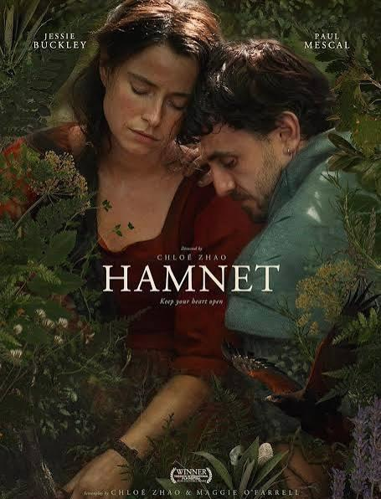

Charlie’s Shop & Café Colwinston

Daily shop provisions and full Cafe offerings.
Thanks for supporting a Village business.

Oil Delivery


The next Oil delivery will be from 1st May 2026

Village Hall

Due to the current and ongoing situation in the Middle East leading to oil prices being almost double their seasonal average, for the May delivery our recommendation is to only order oil if you absolutely need to and to order a smaller quantity e.g. 200 litres.

Oil4Wales have agreed to an additional syndicate delivery in July (normal schedule is August) after which time we will review the situation and schedule.

For any questions regarding the oil syndicate please contact me:

Brett Clee
Tel: 07780 993196

Colwinston Village Community Website

Website Link - https://www.colwinston.info/

Sycamore Tree

Join us every Saturday as we serve delicious food all day from 12pm to 8pm – perfect for a relaxed lunch or evening bite.

Throughout May, enjoy 10% off all food every Thursday – the ideal excuse for a midweek treat!

Quiz Night

Get your thinking caps on for our Quiz Night on Sunday 10th May. Entry is just £1 per person, with teams of up to 6 people. Gather your friends and see if you’ve got what it takes to win!

Father’s Day

We’re also now taking bookings for Father’s Day Sunday Lunch on 21st June, served from 12pm to 4pm. Treat Dad to something special – spaces are filling fast, so be sure to reserve your table.

And don’t forget, alongside our main menu, we also offer weekly specials and a selection of tasty bar snacks.

There’s always something new to enjoy. We look forward to welcoming you soon!

Our opening hours:

- Monday & Tuesday - Closed
- Wednesday to Friday- 5pm to 10pm (last food orders 8pm)
- Saturday - 12pm to 10pm (serving food all day last food orders 8pm)
- Sunday - 12pm to 8pm (Sunday lunch served 12pm to 3pm)

Team Sycamore
www.thesycamoretree.co.uk
Tel: 01656 652827



Little Known Village Facts

Over many years the village maps have been drawn by Janet Thomas, Cordelia Welsby, Terry Morgan and the latest superbly created by the late Carl Hadley.

Also, some time ago, the National Library of Wales were offered copies of the village newsletter as they were short of items of Welsh rural social history.

So, Liz and I had a little jaunt to Aberystwyth and handed over copies of the first 100 editions (thanks to Alan McNee). They haven’t been in touch since!

Terry Morgan

